***Understanding and Working with Routes***

<http://localhost:3000/>

<http://localhost:3000/contact>

Nodemon.IO

<https://nodemon.io/>

npm install -g nodemon

**Activate Nodemon:**

nodemon server.js

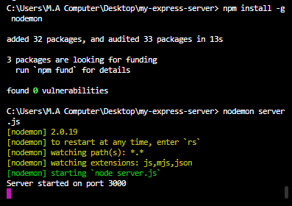

When we add nodemon then when we do changes in code then it will automatically add and we don’t need to save the changes again and again. Nodemon automatically restarts as shown in below pic.

<http://localhost:3000/hobbies>

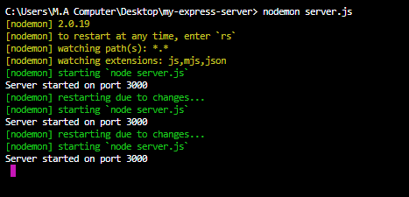

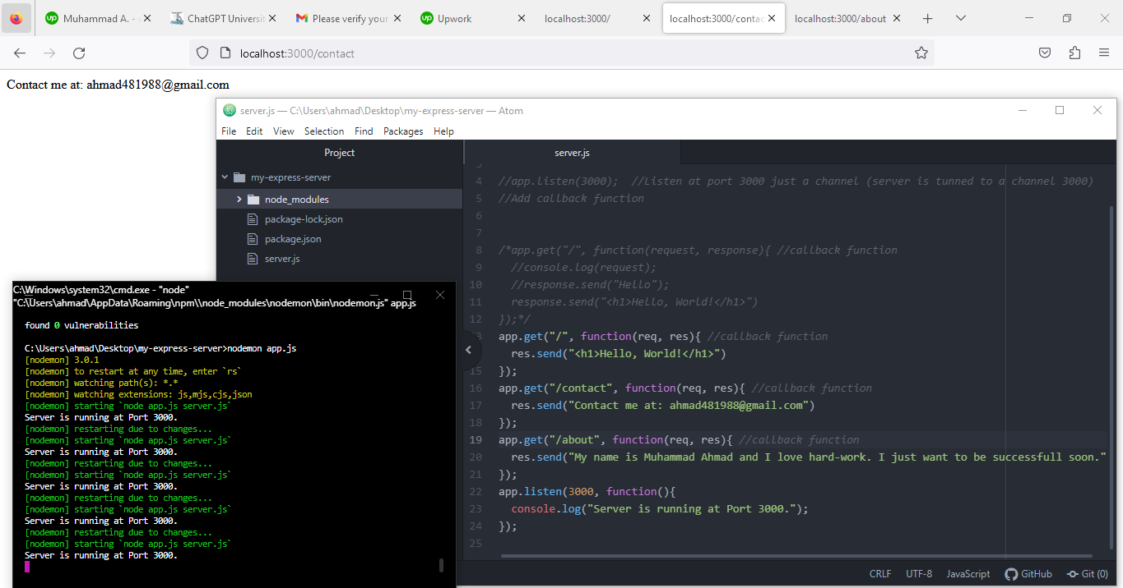

const express = require('express');

const app = express();

//app.listen(3000); //Listen at port 3000 just a channel (server is tunned to a channel 3000)

//Add callback function

/*app.get("/", function(request, response){ //callback function

//console.log(request);

//response.send("Hello");

response.send("<h1>Hello, World!</h1>")

});*/

app.get("/", function(req, res){ //callback function

res.send("<h1>Hello, World!</h1>")

});

app.get("/contact", function(req, res){ //callback function

res.send("Contact me at: ahmad481988@gmail.com")

});

app.get("/about", function(req, res){ //callback function

res.send("My name is Muhammad Ahmad and I love hard-work. I just want to be successfull soon.")

});

app.listen(3000, function(){

console.log("Server is running at Port 3000.");

});